* 0000800000001 * DFD


Cambridge IGCSE™

Ma Qingchuan

FIRST LANGUAGE ENGLISH 0500/12
Paper 1 Reading February/March 2026

2 hours
You must answer on the question paper. You will need: Insert (enclosed)

INSTRUCTIONS
- Answer all questions.
- Use a black or dark blue pen.
- Write your name, centre number and candidate number in the boxes at the top of the page.
- Write your answer to each question in the space provided.
- Do not use an erasable pen. Do not use correction fluid or tape.
- Do not write on any bar codes.
- If additional space is needed, you should use the lined pages at the end of this booklet; the question number or numbers must be clearly shown.
- Dictionaries are not allowed.

INFORMATION
- The total mark for this paper is 80.
- The number of marks for each question or part question is shown in brackets [ ].
- The insert contains the reading texts.

This document has 16 pages. Any blank pages are indicated.

DC (DE) 357574/4
© Cambridge University Press & Assessment 2026

[Turn over

* 7 4 0 9 7 6 0 2 1 4 *

DO NOT WRITE IN THIS MARGIN
DO NOT WRITE IN THIS MARGIN
DO NOT WRITE IN THIS MARGIN
DO NOT WRITE IN THIS MARGIN
DO NOT WRITE IN THIS MARGIN
* 0000800000002 * DFD


2

Read Text A, Giraffes, the climate and us, in the insert and then answer Questions 1(a)–(e) on this question paper.

Question 1

- How many years did researchers spend studying giraffes in Tanzania according to the text?

10 ✅

- Using your own words, explain what the text means by:

‘widespread decline’ (line 1) A large drop of numbers happening across many places.✅

‘combined effects’ (line 2) The joint effect of climate change and human activities working together. ❌ -1

没有用自己的词语解释 effects，可以用 consequence(s) / outcome(s)
- Reread paragraph 2 (‘“Studying … years.”’).

Give two different reasons why the study had to go on for so long.

To observe both the immediate and long-term effects on giraffe survival and to collect enough information over different seasons and years so clear patterns could be found. ✅
- Reread paragraphs 3 and 4 (‘Her team … the leaves.’).

  - Identify two findings that surprised the researchers.

First,higher temperatures actually improved the survival of adult giraffes instead of harming them.Second,wetter rainy seasons reduced the survival of both adult giraffes and calves.✅
  - Explain the reasons scientists gave for what they found out about giraffe survival.

Scientists believed that more parasites and diseases appear during wet seasons, especially after flooding, causing more giraffes to die. They also suggested that when plants grow very quickly, the leaves become less nutritious, so adult giraffes receive poorer-quality food, reducing their chances of survival. ✅

© Cambridge University Press & Assessment 2026 0500/12/F/M/26

DO NOT WRITE IN THIS MARGIN
DO NOT WRITE IN THIS MARGIN
DO NOT WRITE IN THIS MARGIN
DO NOT WRITE IN THIS MARGIN
DO NOT WRITE IN THIS MARGIN
* 0000800000003 * DFD


3

- Reread paragraph 5 (‘Worse still … to blame.’).

Using your own words, explain why people may not have noticed changes in giraffe numbers.

People still see giraffes regularly in zoos, safaris, films and fashion, so they think the animals are common. At the same time, public attention has focused more on endangered animals like elephants and rhinos, meaning the sharp fall in giraffe numbers was mostly ignored. ❌ -1

人们不能在 safaris 中有规律地见到长颈鹿，可以用 encountered on safari
DO NOT WRITE IN THIS MARGIN
DO NOT WRITE IN THIS MARGIN
DO NOT WRITE IN THIS MARGIN
DO NOT WRITE IN THIS MARGIN
DO NOT WRITE IN THIS MARGIN
* 0000800000004 * DFD


4

Read Text B, Who or what is Sophie the giraffe?, in the insert and answer Question 1(f) on this question paper.

- According to Text B, what is appealing about Sophie the giraffe to modern parents of young children?

You must use continuous writing (not note form) and use your own words as far as possible.

Your summary should not be more than 120 words.

Up to 10 marks are available for the content of your answer and up to 5 marks for the quality of your writing.
第一次回答
People like Sophie because she is attractive, safe and environmentally friendly. She is still carefully made by hand in the same French factory where she was first created, giving parents confidence in its quality. The toy is painted with food-safe paint and produced from natural rubber collected without damaging the trees, making it biodegradable and sustainable. Sophie also helps babies develop their senses through her bright appearance, soft texture, squeaky sound and pleasant vanilla scent. She is easy for small hands to hold and has remained popular for generations. In addition, many related products are available, while the original version continues to receive awards and is trusted by families worldwide.

第二次修改
Modern parents are attracted to Sophie because she is made especially for babies and is easy for little hands to hold. She is also stylish and widely recognised, making her a popular choice for families. Many children quickly become emotionally attached to her and take her everywhere. Parents trust her because she is still produced by hand in the original French factory using safe, non-toxic paint. As she is made from natural rubber that does not harm trees, she is environmentally friendly. Sophie also encourages babies to use their senses through her colours, texture, sound and smell. Besides the classic toy, many matching products are available, and the original version has received awards.

DO NOT WRITE IN THIS MARGIN
DO NOT WRITE IN THIS MARGIN
DO NOT WRITE IN THIS MARGIN
DO NOT WRITE IN THIS MARGIN
DO NOT WRITE IN THIS MARGIN
* 0000800000006 * DFD


6

Read Text C, Emil and the giraffes, in the insert and then answer Questions 2(a)–(d) on this question paper.

Question 2

- Identify a word or phrase from the text which suggests the same idea as the words underlined:

  - The shipping director hardly takes his eyes off the papers on his desk as Emil is guided into the office.
第一次回答 IDK
第二次修改 barely looking up
  - People creating spacesuits want to replicate the characteristics of giraffe skin.

第一次回答 imitate
第二次修改 mitate its qualities

  - The sailor explains the general features of how they intend to get the giraffes off the ship.

第一次回答 outlines
第二次修改 outlines the plan
  - Emil speaks his concerns to the zoo manager.

voice my misgivings

- Using your own words, explain what the writer means by each of the words underlined:

That afternoon, I sit in the ship’s library, sifting through documents estimating shipping costs, profit and loss, until I find the veterinary report. I make notes on the blood-pressure measurements recorded for one unfortunate giraffe before its voyage ended.

  - sifting
第一次回答 Looking through something carefully to find useful information.
第二次修改 Searching carefully through information to find something important.
  - Estimating
第一次回答 Calculating or working out roughly.
第二次修改 Making a rough calculation or guess.
  - recorded
第一次回答 Written down
第二次修改 Written down carefully so the information is kept for future reference.
DO NOT WRITE IN THIS MARGIN
DO NOT WRITE IN THIS MARGIN
DO NOT WRITE IN THIS MARGIN
DO NOT WRITE IN THIS MARGIN
DO NOT WRITE IN THIS MARGIN
* 0000800000007 * DFD


7

- Use one example from the text below to explain how the writer suggests what Emil might be thinking and feeling during the ride in the lorry.

Use your own words in your explanation.

Days later, I’m journeying onwards to the zoo in a lorry carrying four of the giraffes, including Snowstorm. Bemused schoolchildren on buses catch sight of the giraffes and wave. The woods we pass are increasingly dense, not the vast, open woodlands giraffes dream of. We rattle along bumpy back roads, avoiding bridges, turning north towards the mountains along the border. ‘Slower,’ I tell the driver. The narrow window in the back of the cab seems to frame the giraffes’ captivity. Their eyes are shut tight.
回答可以用电子版写在这里

第一次回答：
This suggests Emil feels sad and guilty because the giraffes are trapped and cannot escape. The small window makes them look as if they are being displayed like objects, reminding Emil that they have lost their freedom and are far away from their natural home.

第二次修改：
The writer says, “The narrow window in the back of the cab seems to frame the giraffes’ captivity.” This suggests that Emil realises the giraffes are trapped and have lost their freedom. Seeing them through the small window makes him think of them as prisoners rather than wild animals, so he feels sad and sympathetic towards them.

DO NOT WRITE IN THIS MARGIN
DO NOT WRITE IN THIS MARGIN
DO NOT WRITE IN THIS MARGIN
DO NOT WRITE IN THIS MARGIN
DO NOT WRITE IN THIS MARGIN
* 0000800000008 * DFD

8

- Reread paragraphs 12 and 16.

- Paragraph 12 begins ‘One hour later …’ and is about the first encounter with the giraffes.
- Paragraph 16 begins ‘Next morning …’ and is about the morning’s activity at the port.

Explain how the writer uses language to convey meaning and to create effect in these paragraphs. Choose three examples of words or phrases from each paragraph to support your answer. Your choices should include the use of imagery.

Write about 200 to 300 words.

Up to 15 marks are available for the content of your answer.
这个回答要写在本上，拍照放在这里

In paragraph 12, the writer uses language to show that the giraffes are both beautiful and unusual. The phrase "scrape the sky" exaggerates how tall they are. It makes them seem huge and powerful, and shows how amazed Emil is when he first sees them. The simile "flow as if underwater" describes their slow and smooth movements. This makes the giraffes seem calm and graceful. The comparison "like enormous hand-puppets" creates a strange image because only their necks can be seen above the crates. It reminds us that they are trapped and controlled by humans instead of living freely.

In paragraph 16, the writer changes the mood to show the giraffes' fear. The phrase "panic at the sensation of flying" shows that the giraffes do not understand what is happening. They are frightened as they are lifted into the air. The image "shimmering hot with fear" suggests that their fear is so strong that it almost becomes visible. This helps the reader imagine how terrified they are. Finally, the sailor says, "They'll never walk on their continent again." This makes the reader feel sad because the giraffes will never return to their natural home. It also shows that they have lost their freedom forever. Overall, the writer uses these descriptions to make the reader admire the giraffes while also feeling sympathy for them and understanding Emil's growing sadness about what is happening.

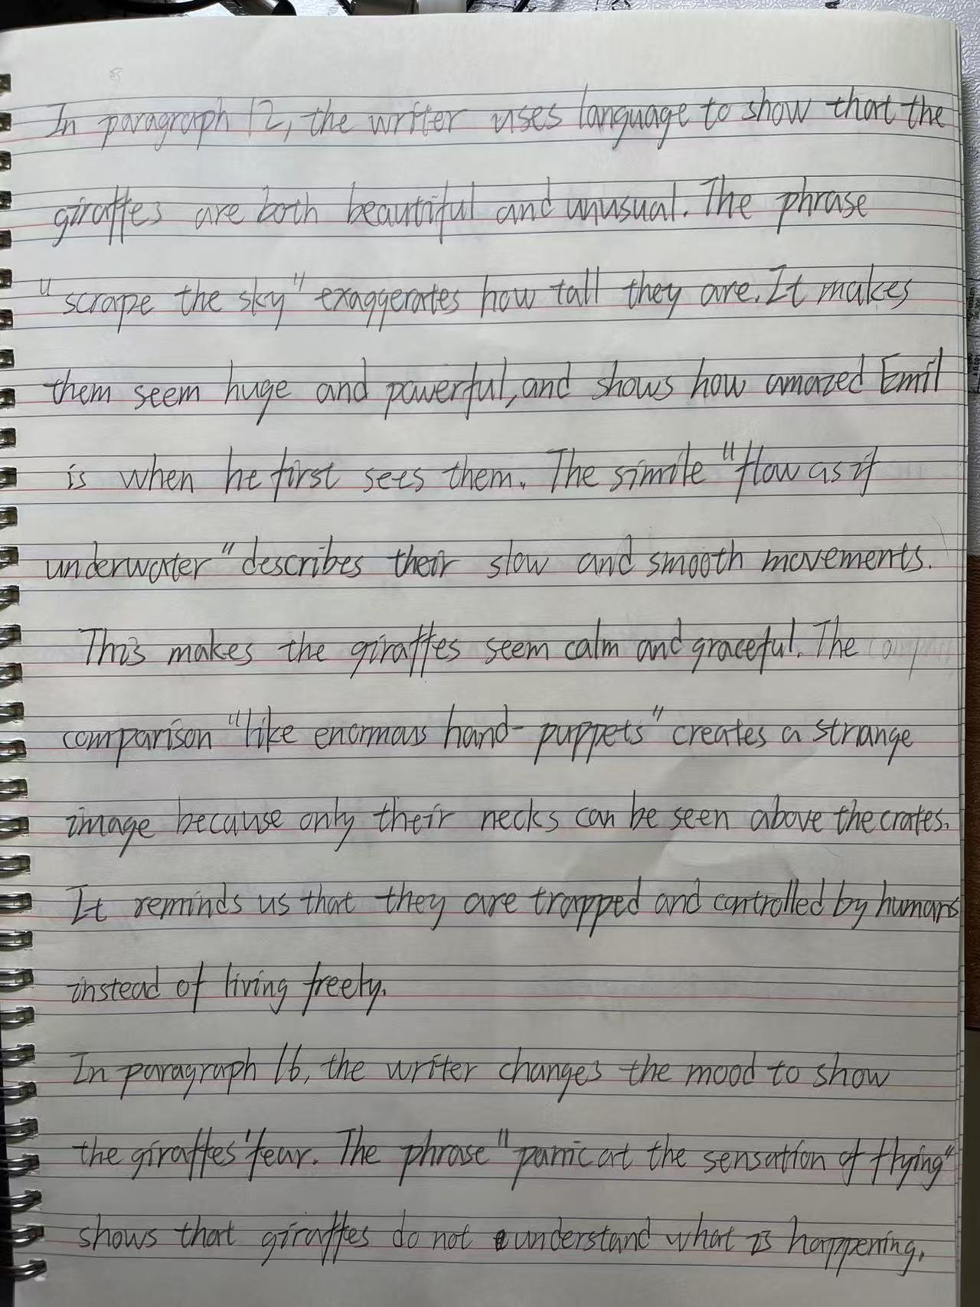

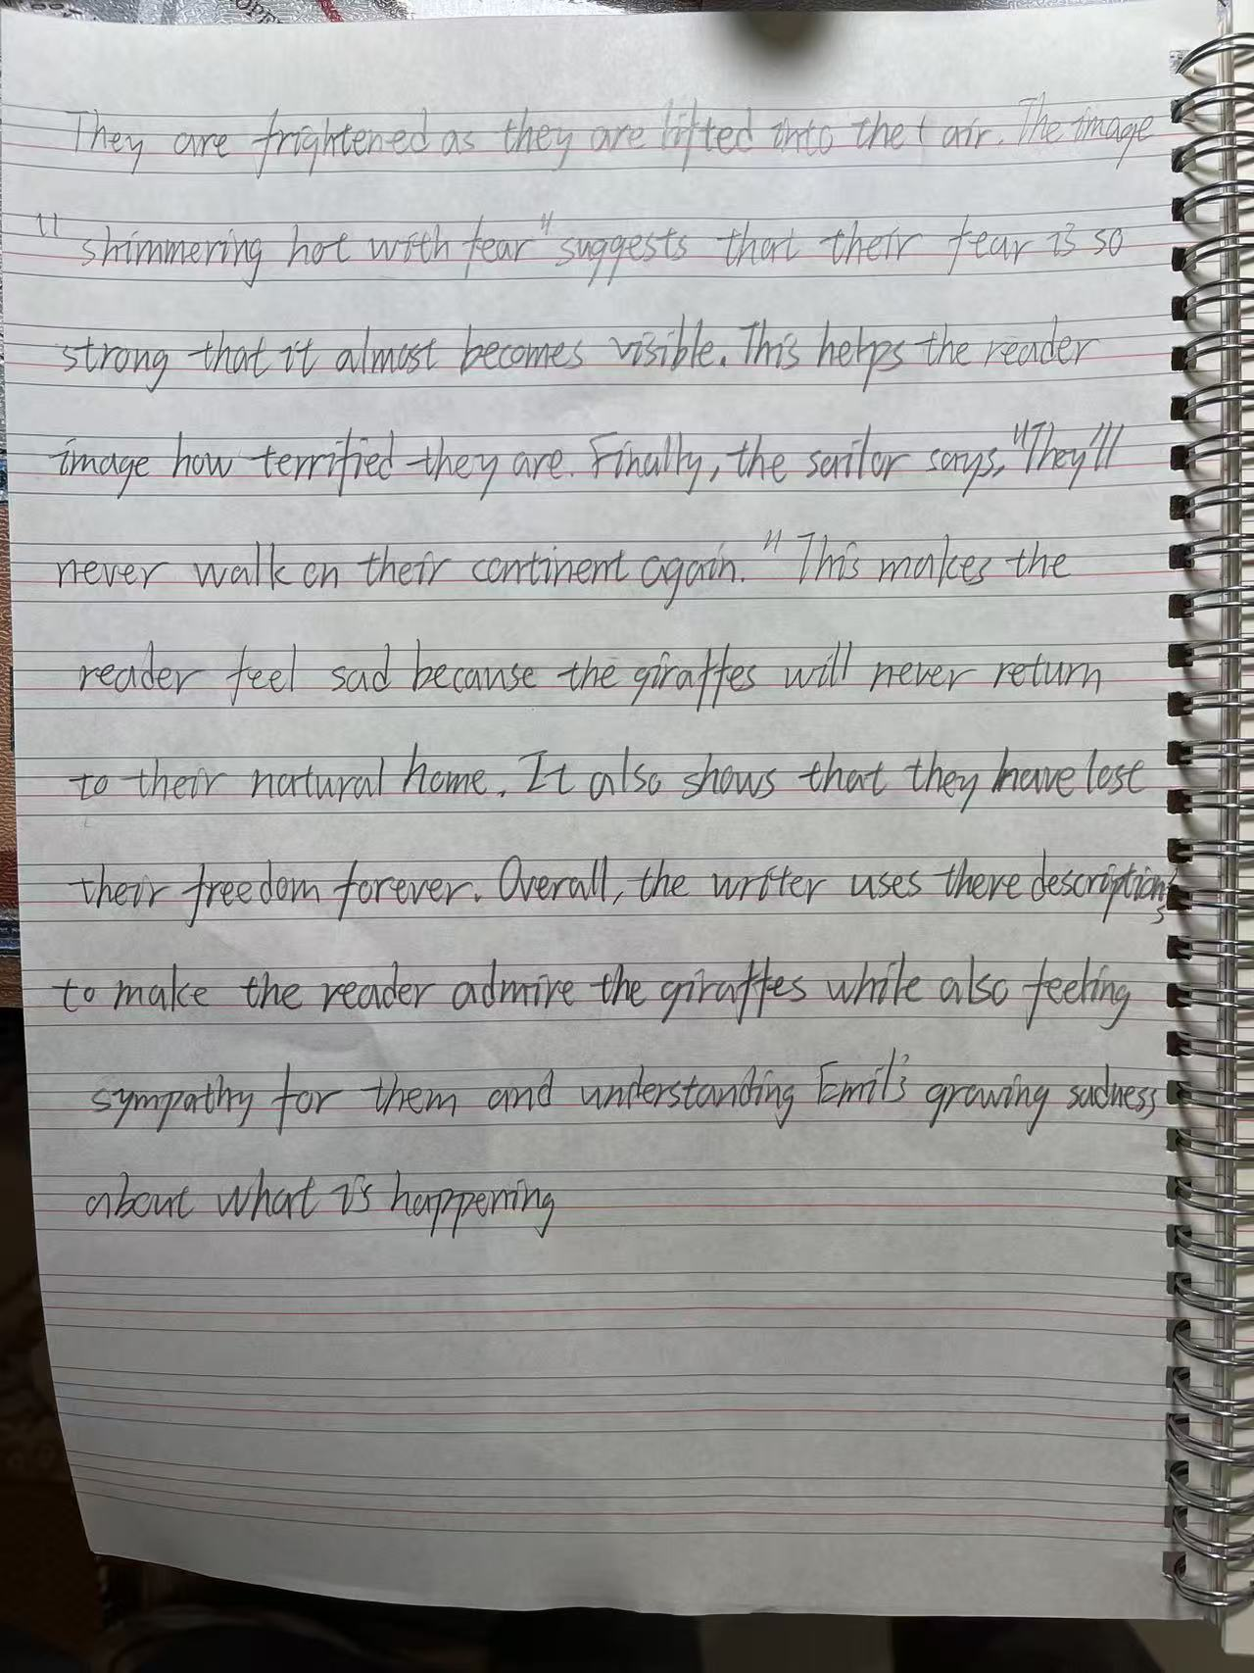
DO NOT WRITE IN THIS MARGIN
DO NOT WRITE IN THIS MARGIN
DO NOT WRITE IN THIS MARGIN
DO NOT WRITE IN THIS MARGIN
DO NOT WRITE IN THIS MARGIN
* 0000800000010 * DFD

10

Reread Text C, Emil and the giraffes, in the insert and then answer Question 3 on this question paper.

Question 3

You are Emil. After you leave the zoo, you decide to share your concerns about the giraffes with an animal welfare charity. The charity asks you to write a report.

In your report, you should explain:

- how you were involved with these giraffes and your impressions of the people you met at that time
- what worried you about the different stages of the giraffes’ journey
- why you feel this zoo is not a suitable place for the giraffes to live.

Write the words of the report.

Base your report on what you have read in Text C, but be careful to use your own words. Address each of the three bullets.

Write about 250 to 350 words.

Up to 15 marks are available for the content of your answer and up to 10 marks for the quality of your writing.

Question 3 以前练过，现在先不练，重点练习前面的题目！！！

Report on the Transport of Thirty-Three Giraffes

I am writing this report to describe my experience of helping transport a group of giraffes from Africa to a zoo. I hope my observations will encourage your organisation to investigate how these animals are treated.

I became involved after my shipping company discovered that I had studied giraffes at university. I was asked to supervise the unloading of the animals at the port and then accompany them by river and road to their final destination. During this journey, I met several people. The sailor seemed kind and experienced. He respected the giraffes and even felt sorry that they would never return to their homeland. In contrast, the zoo manager cared far more about attracting visitors than about the animals' welfare. He ignored my concerns and treated the giraffes as valuable exhibits instead of living creatures.

There were many things that worried me during the journey. Even before unloading began, the giraffes had already spent a long time in wooden crates with little freedom to move. When they were lifted by harnesses onto the barge, several became frightened and kicked wildly because they did not understand what was happening. Later, the lorry journey was also difficult. The rough roads caused the vehicle to shake constantly, and the giraffes looked exhausted. They kept their eyes closed for most of the journey, which suggested they were under great stress. I was also saddened to know that one giraffe had died before reaching the port.

I strongly believe that this zoo is not a suitable place for these animals. Instead of the wide open woodlands they are adapted to, they would have to live in a cold mountain climate surrounded by fences. The manager planned to keep them outside simply to attract more tourists, without considering whether the environment matched their natural needs. These giraffes have already lost their freedom, and I fear they will continue to suffer unless their living conditions are greatly improved.

